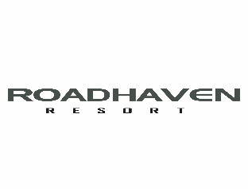
At Roadhaven, the health and well-being of our residents, guests, and staff members is our priority. As COVID-19 is still a widespread concern, Federal, State, and local governments continue to recommend or mandate restrictions. We want to continue providing you with as much information as possible about our efforts to help keep our residents, guests, and staff safe and healthy.
We will continue to closely monitor the Centers for Disease Control and Prevention (CDC) statements regarding the novel form of coronavirus (COVID-19) and following guidelines from this agency and other local and state governmental agencies.
Health & Safety Protocols- A Cooperative Effort
COVID-19 is a new disease and health officials are still learning about how it spreads and the severity of illness it causes. According to the most recent information published by the CDC, it’s critical we all do our part to limit the spread of COVID-19 by keeping the following in mind:
- The virus is thought to spread mainly between people who are in close contact with one another (within about 6 feet).
- Recent studies suggest COVID-19 may be spread by people who are not showing symptoms.
- Maintaining good social distance (about 6 feet) is especially important.
- Cover your mouth and nose with a face covering when around others.
- Do not gather in groups and avoid crowded places and mass gatherings.
- If someone in your household is sick, awaiting test results, or has tested positive, keep the entire household at home as recommended by a medical provider.
- Listen to and follow the directions of your state and local authorities.
- Information from the ongoing pandemic suggests the virus is spreading more efficiently than influenza.
- The CDC recommends people practice frequent hand washing or use of alcohol-based hand sanitizer.

OUR RECOMMENDATIONS:
- We are strongly encouraging wearing of masks that cover both nose and mouth at all times when you leave your property, inside any common area buildings, and when you are within 6 ft of another resident or guest.
- When you return to the park, please consider limiting your activity outside your property to the greatest extent possible for your first two weeks back. This will help ensure that any exposure you might have experienced during your trip back will have sufficient time to reveal itself.

